PipeWatch Nigeria: Technical Documentation
Oct 13, 2026 · @Johnayy

Overview
PipeWatch Nigeria is a web GIS dashboard that shows where oil and gas pipelines in the Niger Delta are attacked most, so drone and ground patrols can be sent there first. It reads official spill records from the National Oil Spill Detection and Response Agency (NOSDRA) and re-reads them automatically every six hours. At the sync of 13 October 2026 it mapped 9,021 spills from January 2015 to 17 September 2026. In those records, 81% of spills (7,301) were caused by sabotage or third-party interference.
Problem. Pipeline security in the Niger Delta is mostly reactive. Thousands of kilometres of line run through creeks and swamp, and patrols are spread thin. Yet attacks are not random: they cluster on a small number of lines and locations that repeat year after year.
Objectives
- Map every recorded spill and separate sabotage from operational causes.
- Rank pipelines, 5 km pipeline segments and 5 km areas by how often they are attacked, and show whether attacks are rising or falling.
- Turn those rankings into UAV patrol sorties with a length and an estimated flight time.
- Give security agencies and operators one shared, filterable picture of the threat that stays current without manual updates.
Live dashboard: johnedet12.github.io/pipewatch-nigeria
Source code: github.com/JohnEdet12/pipewatch-nigeria
The dashboard is a single web page. It needs no installation or sign-in, and fits one screen on a desktop browser. On a phone it stacks into a scrolling page.

Data sources
Spill incidents come from NOSDRA. The basemap and pipeline routes come from OpenStreetMap (OSM).
Layer | Source | What it provides | Licence | Status
Spill incidents | NOSDRA Oil Spill Monitor bulk feed (21,172 records, all years and regions) | Date, cause, operator, asset type, site name, LGA, coordinates, barrels spilled | Public government data | Live: synced every 6 hours, 9,021 records mapped
Pipeline routes | OpenStreetMap, ways tagged man_made=pipeline, via Overpass API | Line geometry, substance (oil, gas) and name where mapped: about 5,064 km in the delta | ODbL 1.0 | In use: cut into 1,443 segments of up to 5 km
Basemap | OpenStreetMap standard tiles | Roads, rivers, settlements and state names behind the data | ODbL 1.0 | In use
Fallback outline | Natural Earth admin-1 states and river centrelines | Plain outline shown only where OSM tiles cannot load; also assigns each spill to a state | Public domain | In use
NOSDRA records used. Only records that are confirmed or reviewed, dated 2015 or later, not duplicates, and with coordinates inside the Niger Delta study area (3.9°N–7.3°N, 4.3°E–9.1°E) are mapped: 9,021 of 21,172. Blank quantities stay blank; they are never counted as zero.
Automatic updates. A scheduled job downloads the NOSDRA feed every six hours, cleans it, rebuilds the rankings and republishes the dashboard. An open page checks for newer data and reloads itself. If NOSDRA cannot be reached, the last good data stays online. The status chip in the top bar shows when the last sync ran.
https://oilspillmonitor.ng/api/spill-data.php?dataset=nosdra&format=json
OSM extraction. The pipeline query below covers the Niger Delta bounding box (4.0°N–7.2°N, 4.5°E–9.0°E). The result is cached with the dashboard and can be refreshed on demand.
[out:json][timeout:180];
way["man_made"="pipeline"](4.0,4.5,7.2,9.0);
out tags geom;
Attribution. Any map or export that shows OSM layers must credit “© OpenStreetMap contributors”. The dashboard shows this credit on the map.

Methodology
The analysis turns spill points into four patrol rankings: pipelines, 5 km pipeline segments, 5 km cells and UAV sorties.
- Clean and filter the spills. Keep confirmed or reviewed records from 2015 onward with coordinates in the study area. Remove duplicates: the same incident number and date, or the same operator, date, point and quantity. Group NOSDRA cause codes: sab = sabotage / third-party; eqf, cor, ome = operational; ytd, mys = undetermined; oth = other.
- Name the line at each spill. Parse the pipeline name from the NOSDRA site name (for example “24’’ TRANS RAMOS PIPELINE (OIL) @ ODIMODI” becomes Trans Ramos). Spelling variants are merged (Tabidaba and Tebibada become Tebidaba; EOC becomes Ebocha), and two-ended names are matched in either order (Bomu–Bonny = Bonny–Bomu). 92% of sabotage spills carry a line name.
- Attach spills to OSM pipelines. Each OSM pipeline is cut into segments of up to 5 km. Each spill is snapped to the nearest segment within 3 km. 86% of sabotage spills snap to a mapped pipeline.
- Build each line’s route. A named line’s route is the set of OSM segments its own spills snap to. 150 lines have an OSM route. A line that OSM does not map is traced through the median positions of its own spill sites, binned along the main axis of those points. Seven lines use such an approximate trace, including Tebidaba–Brass and Tuomo–Ogboinbiri; they are drawn dashed and labelled “approx. route”.
- Score segments and 5 km cells. Each segment is scored by sabotage spills within 3 km. The delta is also divided into cells of 0.045° (about 5 km), each scored by its sabotage count. Both use the classes 1–4, 5–14, 15–39 and 40 or more.
- Rank pipelines. Each named line is scored by sabotage count, barrels reported, main operator and date of the last attack. Pills mark Critical (150+), High (60–149) and Elevated (20–59).
- Measure the trend. The last 12 months of the selected period are compared with the 12 months before, ending at the last record date.
- Plan UAV sorties. Lines with at least 5 km of route and 10 sabotage spills are ranked by spills per km. Sortie time is the route flown out and back:
t_sortie = (2 × L ÷ v) × 60
where t is minutes, L is route length in km and v is cruise speed in km/h. The default is 70 km/h for a fixed-wing VTOL UAV; users can change it on the dashboard.
Cleaning, naming and snapping run in the data pipeline at each sync. Filtering and scoring run in the browser, so every ranking updates as soon as a filter changes.

Dashboard guide
The dashboard fits one screen: a command bar and filter row at the top, five summary figures, then the map with charts beneath it and the patrol rankings on the right.
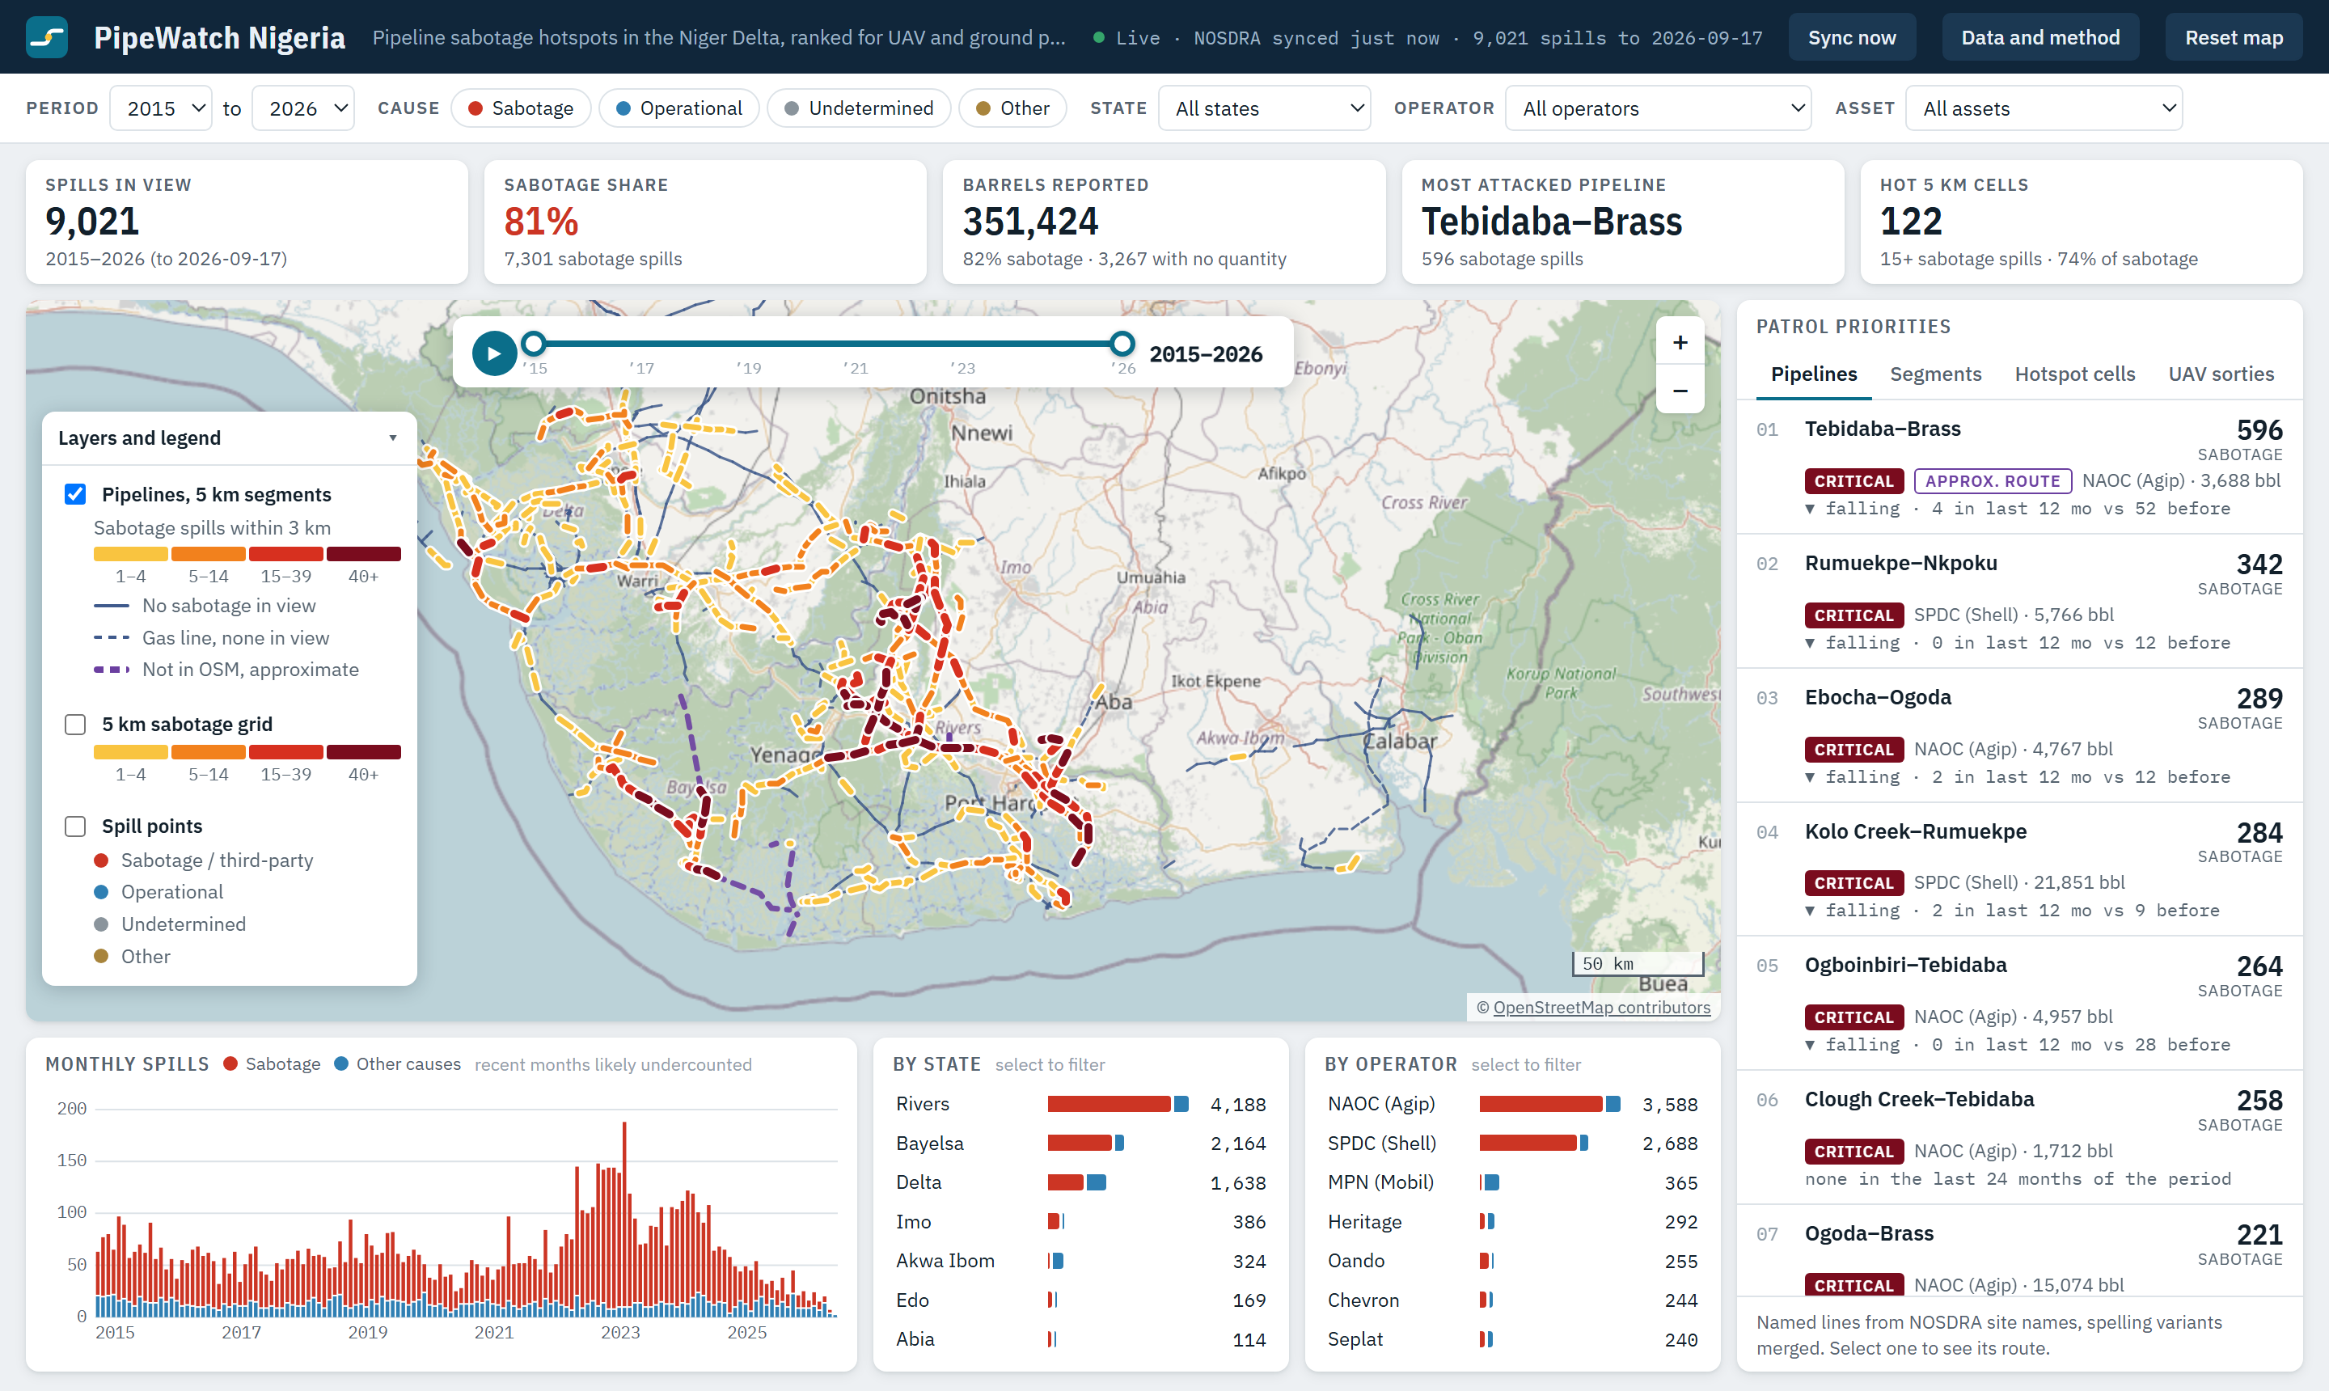

Command bar and filters
The command bar shows the sync status, a Data and method panel and a Reset map button. The filter row sets the period (2015–2026), cause group, state, operator and asset type (pipelines and trunk lines, flowlines, or wellheads and stations). Clear filters appears once any filter is set.

Summary band
Five figures update with every filter: spills in view, the sabotage share, barrels reported, the most attacked pipeline and the number of hot 5 km cells (15 or more sabotage spills).

Map
The map sits on an OpenStreetMap basemap. Pipelines are drawn from OSM geometry in 5 km segments, coloured by sabotage spills within 3 km, from amber (1–4) to dark red (40+). Thin blue lines are mapped pipelines with no sabotage in view; dashed purple lines are approximate routes for lines missing from OSM. Click any segment, cell or point for its details.
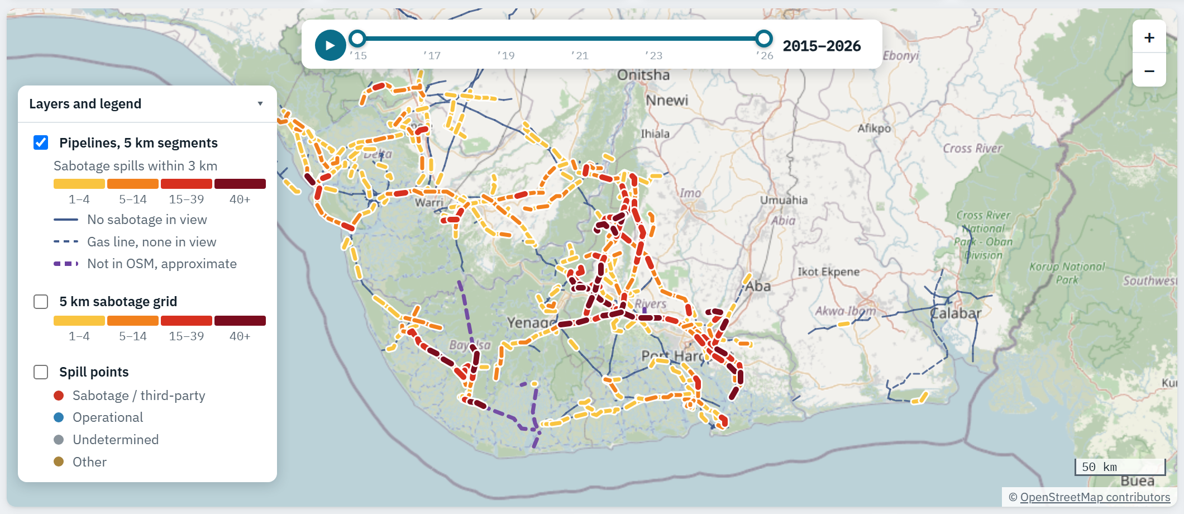
Time slider. The slider at the top of the map sets the start and end year with two handles. The play button steps through one year at a time. It stays in step with the Period filter.
Layers and legend. The collapsible panel at the bottom left of the map switches three layers on and off and explains their colours: pipeline segments (on by default), the 5 km sabotage grid, and spill points coloured by cause.

Patrol priorities
The right-hand panel has four tabs. Selecting a row zooms the map to it and highlights it.
- Pipelines ranks named lines by sabotage spills, with operator, barrels and the 12-month trend.
- Segments ranks 5 km OSM pipeline segments by sabotage spills within 3 km, with the line, LGA and state.
- Hotspot cells ranks 5 km cells by sabotage spills and names the LGA, state and main line in each.
- UAV sorties ranks lines by sabotage spills per km and gives route length and an out-and-back flight time.
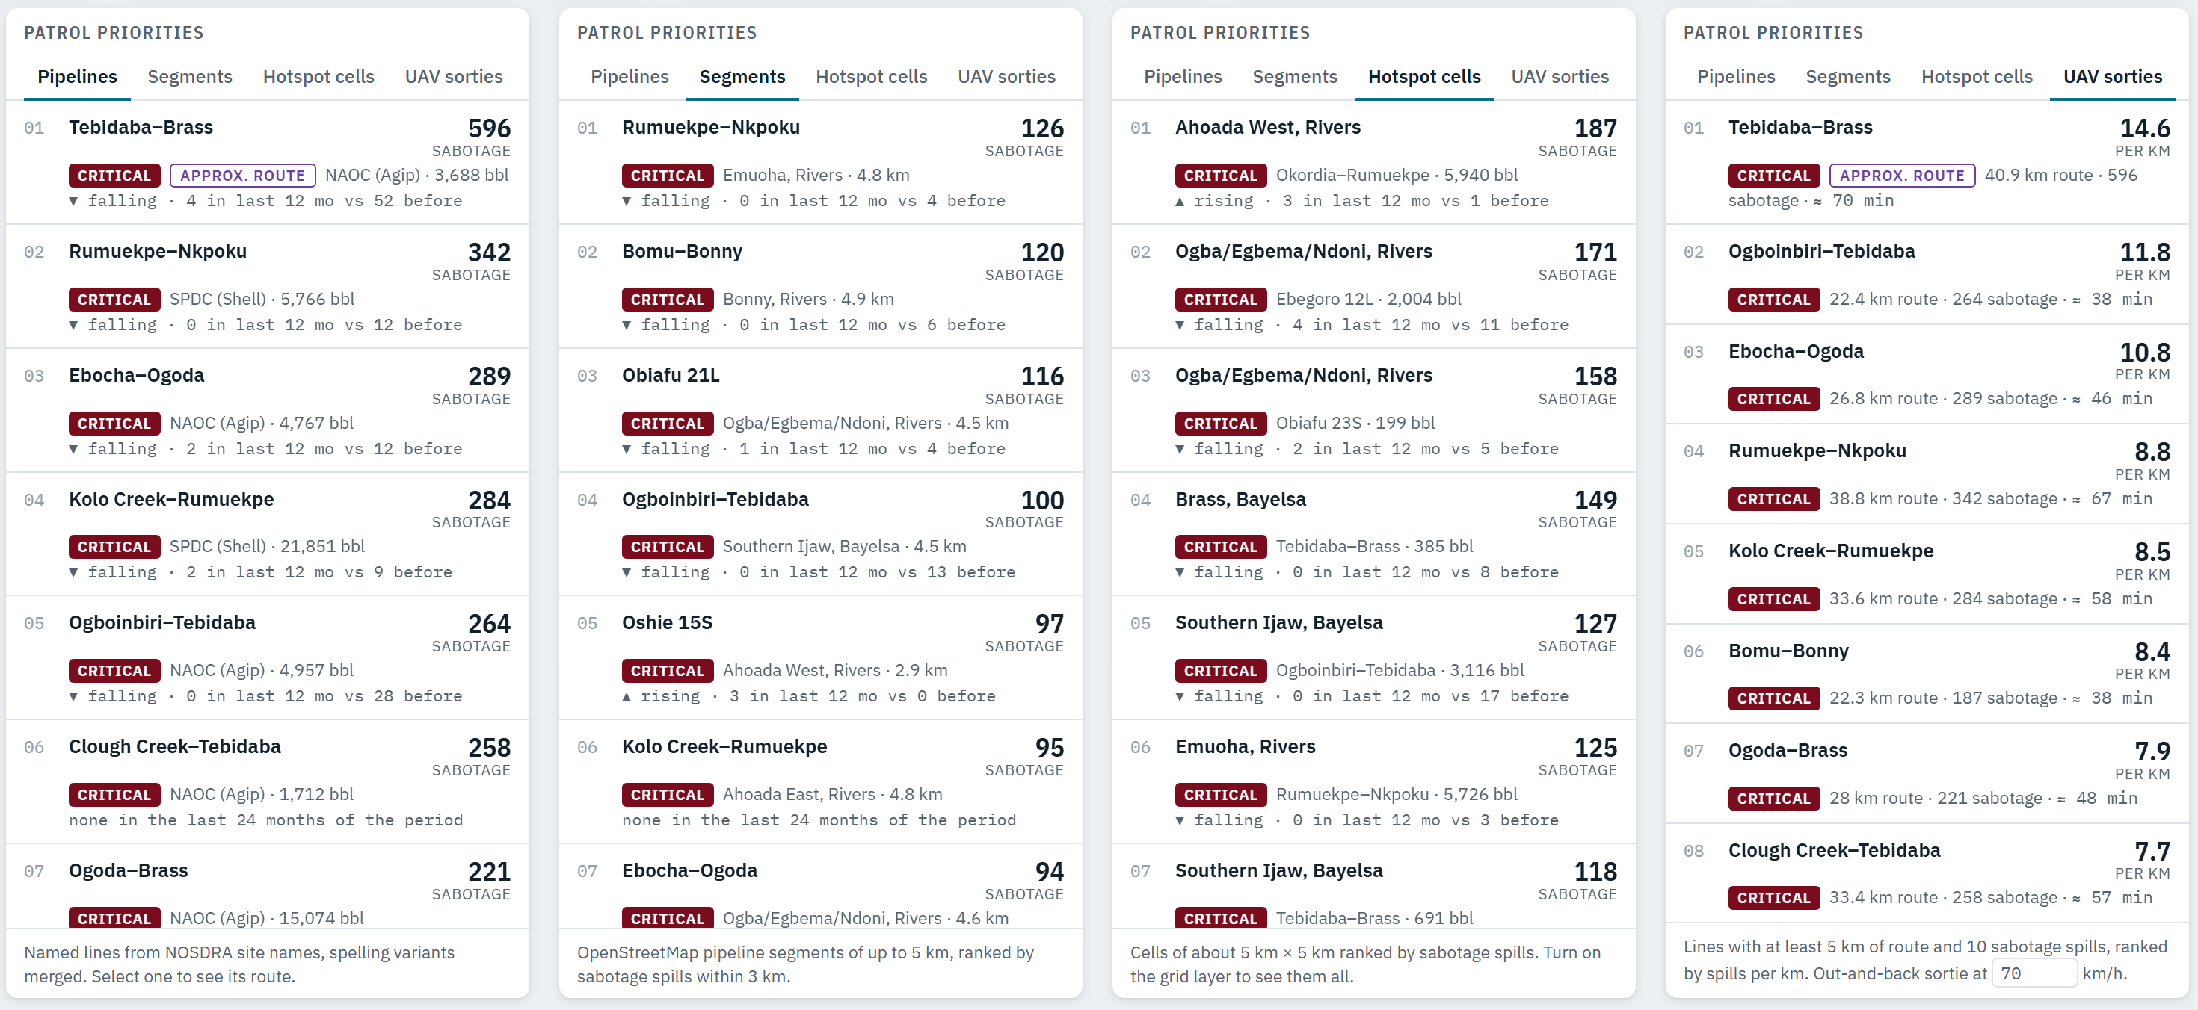

Charts
Monthly spills split sabotage from other causes; hover a month for its counts. Two bar lists show spills by state and by operator, and selecting a bar filters the dashboard to it.
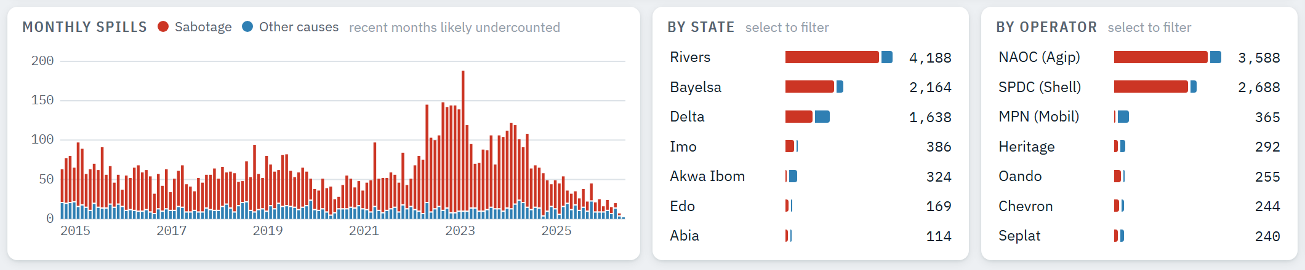

Key findings
Sabotage is the main cause of oil spills in the Niger Delta, and it is concentrated on a few lines and places.
NOSDRA spill records, live feed · 9,021 mapped spills, 2 Jan 2015 to 17 Sep 2026, as synced on 13 Oct 2026. Figures move slightly with each sync.
- Sabotage dominates. 7,301 of 9,021 spills (81%) were sabotage or third-party interference. They account for 288,858 of the 351,424 barrels with a reported quantity (82%).
- Attacks surged in 2022–2024, then fell. Sabotage spills rose from 495 in 2021 to 1,270 in 2023, then fell to 349 in 2025. Part of the recent drop may be reporting lag, since new records are added over time.
- Three states carry 92% of sabotage. Rivers (3,755), Bayelsa (1,896) and Delta (1,054).
- Hotspots are tight. 122 cells of about 5 km hold 74% of all sabotage spills. The top 20 cells alone hold 31%.
- A small share of pipeline carries most attacks. 112 of the 1,443 mapped 5 km segments have 15 or more sabotage spills, and together hold 61% of all sabotage. The worst segment, on Rumuekpe–Nkpoku in Emuoha LGA, has 126.
- Two operators carry most of the exposure. NAOC (Agip) has 3,214 sabotage spills and SPDC (Shell) 2,469, together 78% of the total.
- Most attacks hit pipelines. 73% of sabotage spills were on pipelines and 19% on flowlines.
- Security forces join about a third of investigations. The military attended the Joint Investigation Visit for 32% of sabotage spills.
The ten most attacked lines over the full period:
Pipeline | Sabotage spills | Barrels reported | Spills with no quantity
Tebidaba–Brass | 596 | 3,688 | 195
Rumuekpe–Nkpoku | 342 | 5,766 | 250
Ebocha–Ogoda | 289 | 4,767 | 40
Kolo Creek–Rumuekpe | 284 | 21,851 | 188
Ogboinbiri–Tebidaba | 264 | 4,957 | 34
Clough Creek–Tebidaba | 258 | 1,712 | 38
Ogoda–Brass | 221 | 15,074 | 30
Okordia–Rumuekpe | 213 | 12,650 | 90
Nkpoku–Bomu | 195 | 7,026 | 114
Tuomo–Ogboinbiri | 195 | 511 | 128
These counts are higher than in the earlier version of this document, because more spelling variants are now merged into each line and the live feed holds about 600 more mapped spills than the earlier export.
The LGAs with the most sabotage spills are Southern Ijaw (944), Ogba/Egbema/Ndoni (893), Ahoada West (593) and Emuoha (473).

Limitations
The rankings are only as complete as NOSDRA’s records and OSM’s pipeline mapping.
- Reported, not measured. Causes and volumes are reported by operators and confirmed through Joint Investigation Visits. 36% of mapped spills have no quantity.
- Reporting lag. Records are added over time, so the most recent months are likely undercounted. The 2025–2026 fall should be read with that in mind.
- Incomplete pipeline mapping. OSM does not map every line in the delta, and route accuracy varies by contributor. The most attacked line, Tebidaba–Brass, is not in OSM; its dashed trace shows where attacks occur but is not a surveyed centreline. 14% of sabotage spills are more than 3 km from any mapped pipeline.
- Few named OSM lines. Only a handful of OSM pipelines carry a name, so line names come from NOSDRA and routes are inferred from where each line’s spills snap. Where two lines run side by side, a spill can snap to the wrong one.
- Name matching. Line names come from free-text site names. Most spelling variants are merged, but some remain, and a few distinct lines may have been merged in error.
- Automated cleaning. The live pipeline applies simpler rules than the hand-checked workbook used earlier. It reproduces 8,384 of that workbook’s 8,425 mapped records and adds about 600 confirmed spills the earlier export left out, most with a blank state field.
- Coordinate precision. Some records have fewer than three decimal places (more than ~110 m uncertainty), so a spill can sit in a neighbouring cell or segment.
- Spills, not all attacks. The data records spills. Attacks that cause no recorded spill, and theft without a leak, are missing.

Roadmap
The next step is a UAV pilot on the most attacked corridor, Tebidaba–Brass in Bayelsa State.
- Pilot design (month 1). Agree the corridor, patrol frequency and reporting chain with the operator and security agencies, and obtain the surveyed route from the operator, since the line is not in OSM. At 70 km/h, one out-and-back sortie over the roughly 41 km approximate route takes about 70 minutes.
- UAV pilot (months 2–4). Fly scheduled sorties over the Critical segments with optical and thermal sensors. Log detections such as illegal taps, fresh hydrocarbon sheen and unusual activity along the right of way.
- Evaluate (month 5). Compare sabotage spills and response times on the pilot corridor with the 12 months before and with similar unpatrolled lines.
- Scale (month 6 onward). Extend to the next ranked corridors (Ogboinbiri–Tebidaba, Ebocha–Ogoda, Rumuekpe–Nkpoku).
Planned dashboard upgrades:
- Surveyed routes for the lines missing from OSM, starting with Tebidaba–Brass and Tuomo–Ogboinbiri.
- LGA boundaries from OSM (admin_level=6) for LGA-level reporting.
- Sentinel-1 radar and Sentinel-2 imagery to flag possible spills between NOSDRA reports.
- A secure login for agencies, with UAV detections logged as a new layer.
Completed since the first version: automatic refresh from NOSDRA, OSM pipeline routes and basemap, the segment ranking, the time slider and public hosting.

References and attribution
- National Oil Spill Detection and Response Agency (NOSDRA). Nigerian Oil Spill Monitor, bulk spill data feed, oilspillmonitor.ng (21,172 records at the 13 October 2026 sync).
- OpenStreetMap contributors. Basemap tiles and pipeline ways (man_made=pipeline), via the Overpass API. © OpenStreetMap contributors, ODbL 1.0.
- Natural Earth. Admin-1 states and river centrelines, 1:10m (public domain), fallback outline and state assignment.
- Leaflet 1.9.4, open-source web mapping library (BSD-2-Clause).

